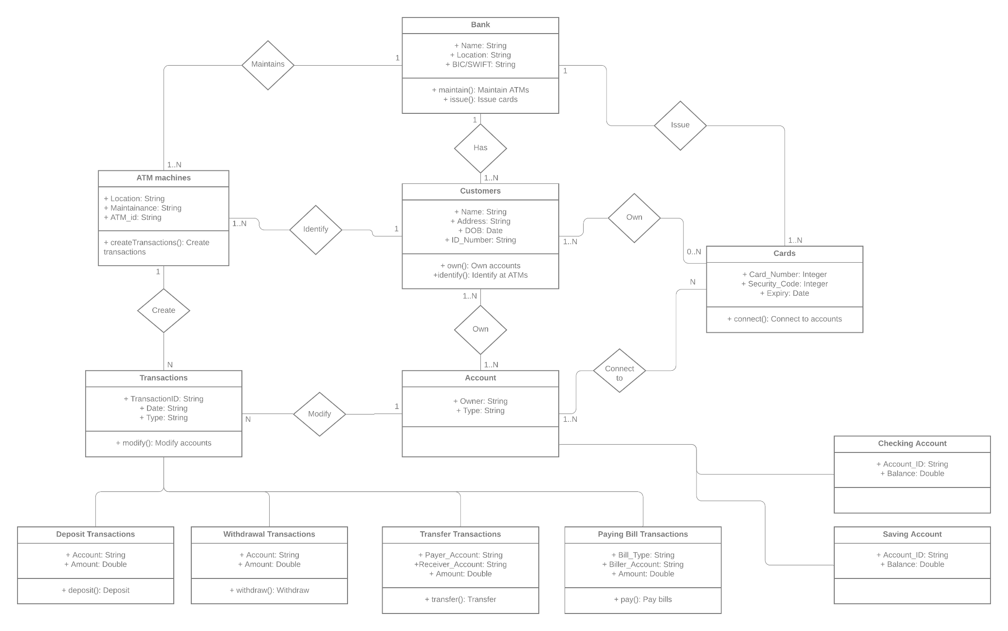

Assumptions: The ATMs are owned by a bank, which has at least one or more customers who own accounts and bank cards offered by the said bank. The ATMs are capable of making transactions, which are in 4 types: deposits, withdrawals, transfers or bill paying. Accounts offered by the banks could be checking or saving accounts. Customers need to identify themselves before using the ATMs.